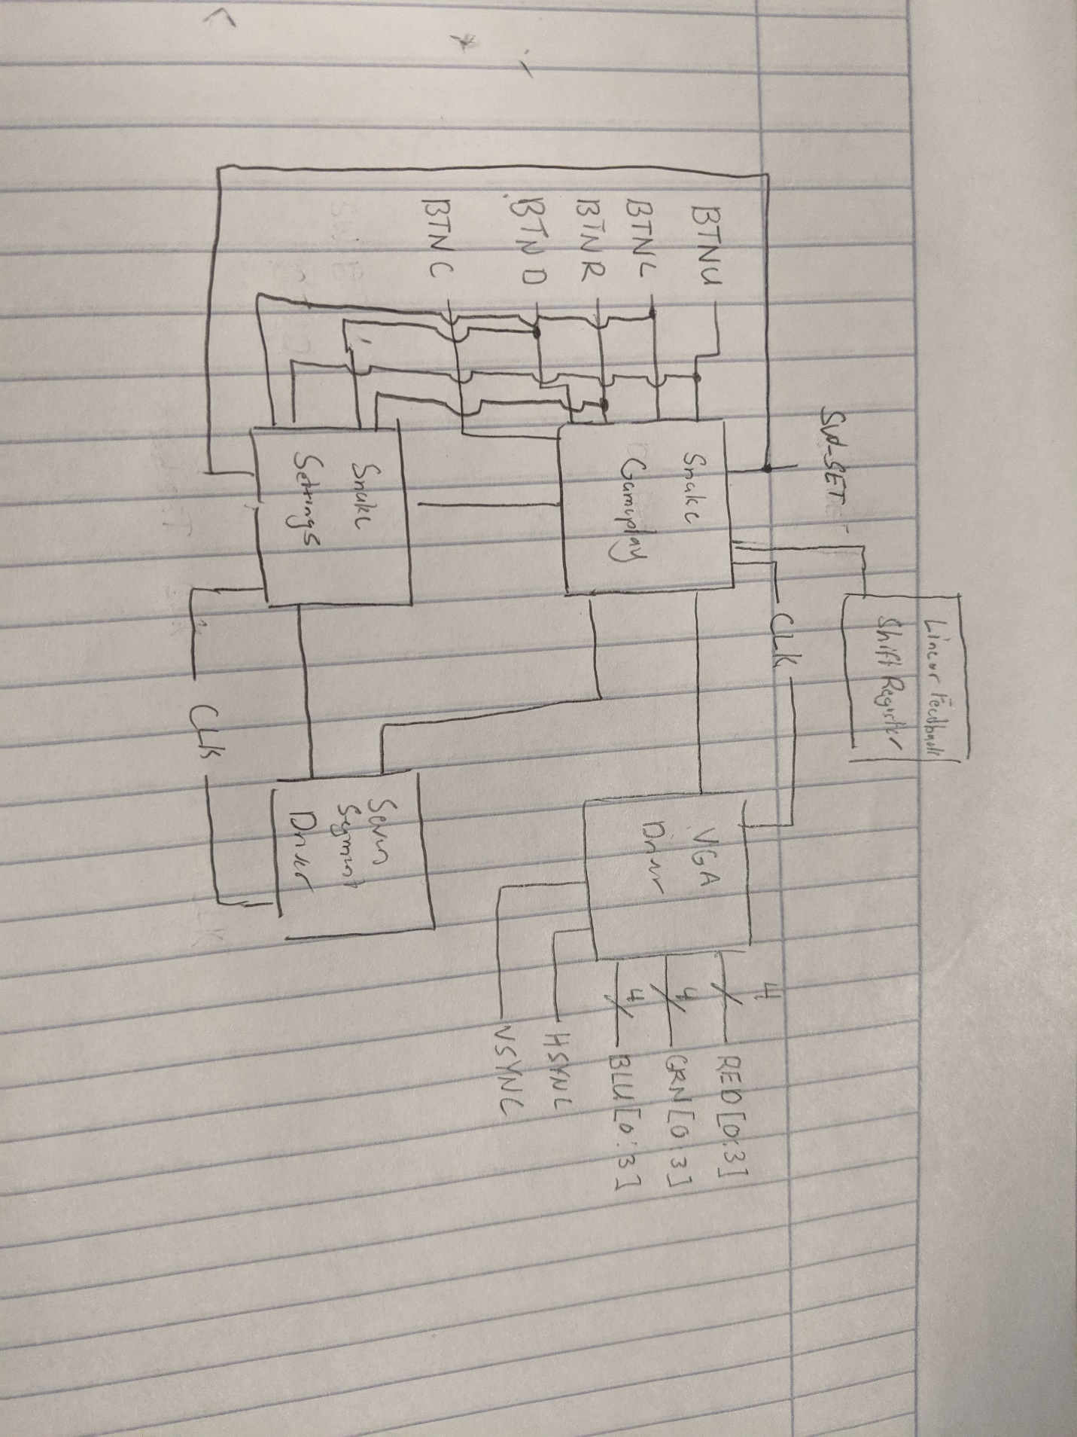Schematic Design for Project Proposal Snake